Feature Plan

**Login/Singnup 1**

**Sign in 2**

**Sign Up 3**

**Manager mode 4**

**Club Members 5**

**RSVP list 6**

**Main Page 7**

Designs 7

Design 1 - Wide 7

Design 2 - Tall 8

Descriptions 8

Title 8

Navigation Bar & Sign in/up 9

Main Content 9

Footer 10

**Admin See all Users 10**

Design 10

Description 11

Title 11

Navigation Bar 11

Main Content 11

Footer 11

**Admin See all Clubs 11**

Design 11

Description 12

Title 12

Navigation Bar 12

Main Content 12

Footer 13

**Club page: 14**

Design 14

Description: 15

**Manage Account: 16**

Design: 16

Description: 17

# Login/Singnup

The screen shots of the plans for Login/signup pages:

Sign in page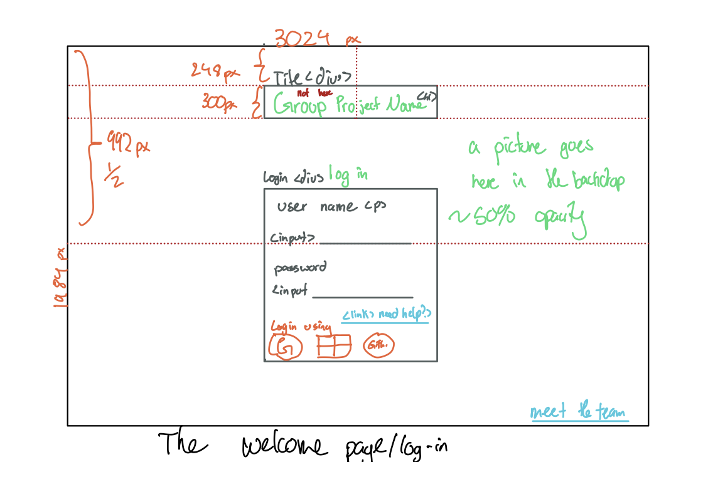

# Sign in

The sign in page is a very simple rudimentary page that takes the user’s input as text for the username and password as an assortment of characters that can be text and special characters.

The main feature of this page is the sign in with google API implementation that will redirect the user to the google sign in API. If the user needs help with their log in issues they could click the need help link that will redirect the user to a page, to reset their password or help find their email.

This design is good in my opinion as it is the best layout for the user’s ergonomics. As when the user first opens the page, their eyes will fall onto the big sign in header that will lead them down to the log-in form. This will also lead them to the Icons below the sign in form.

Sign Up Page:

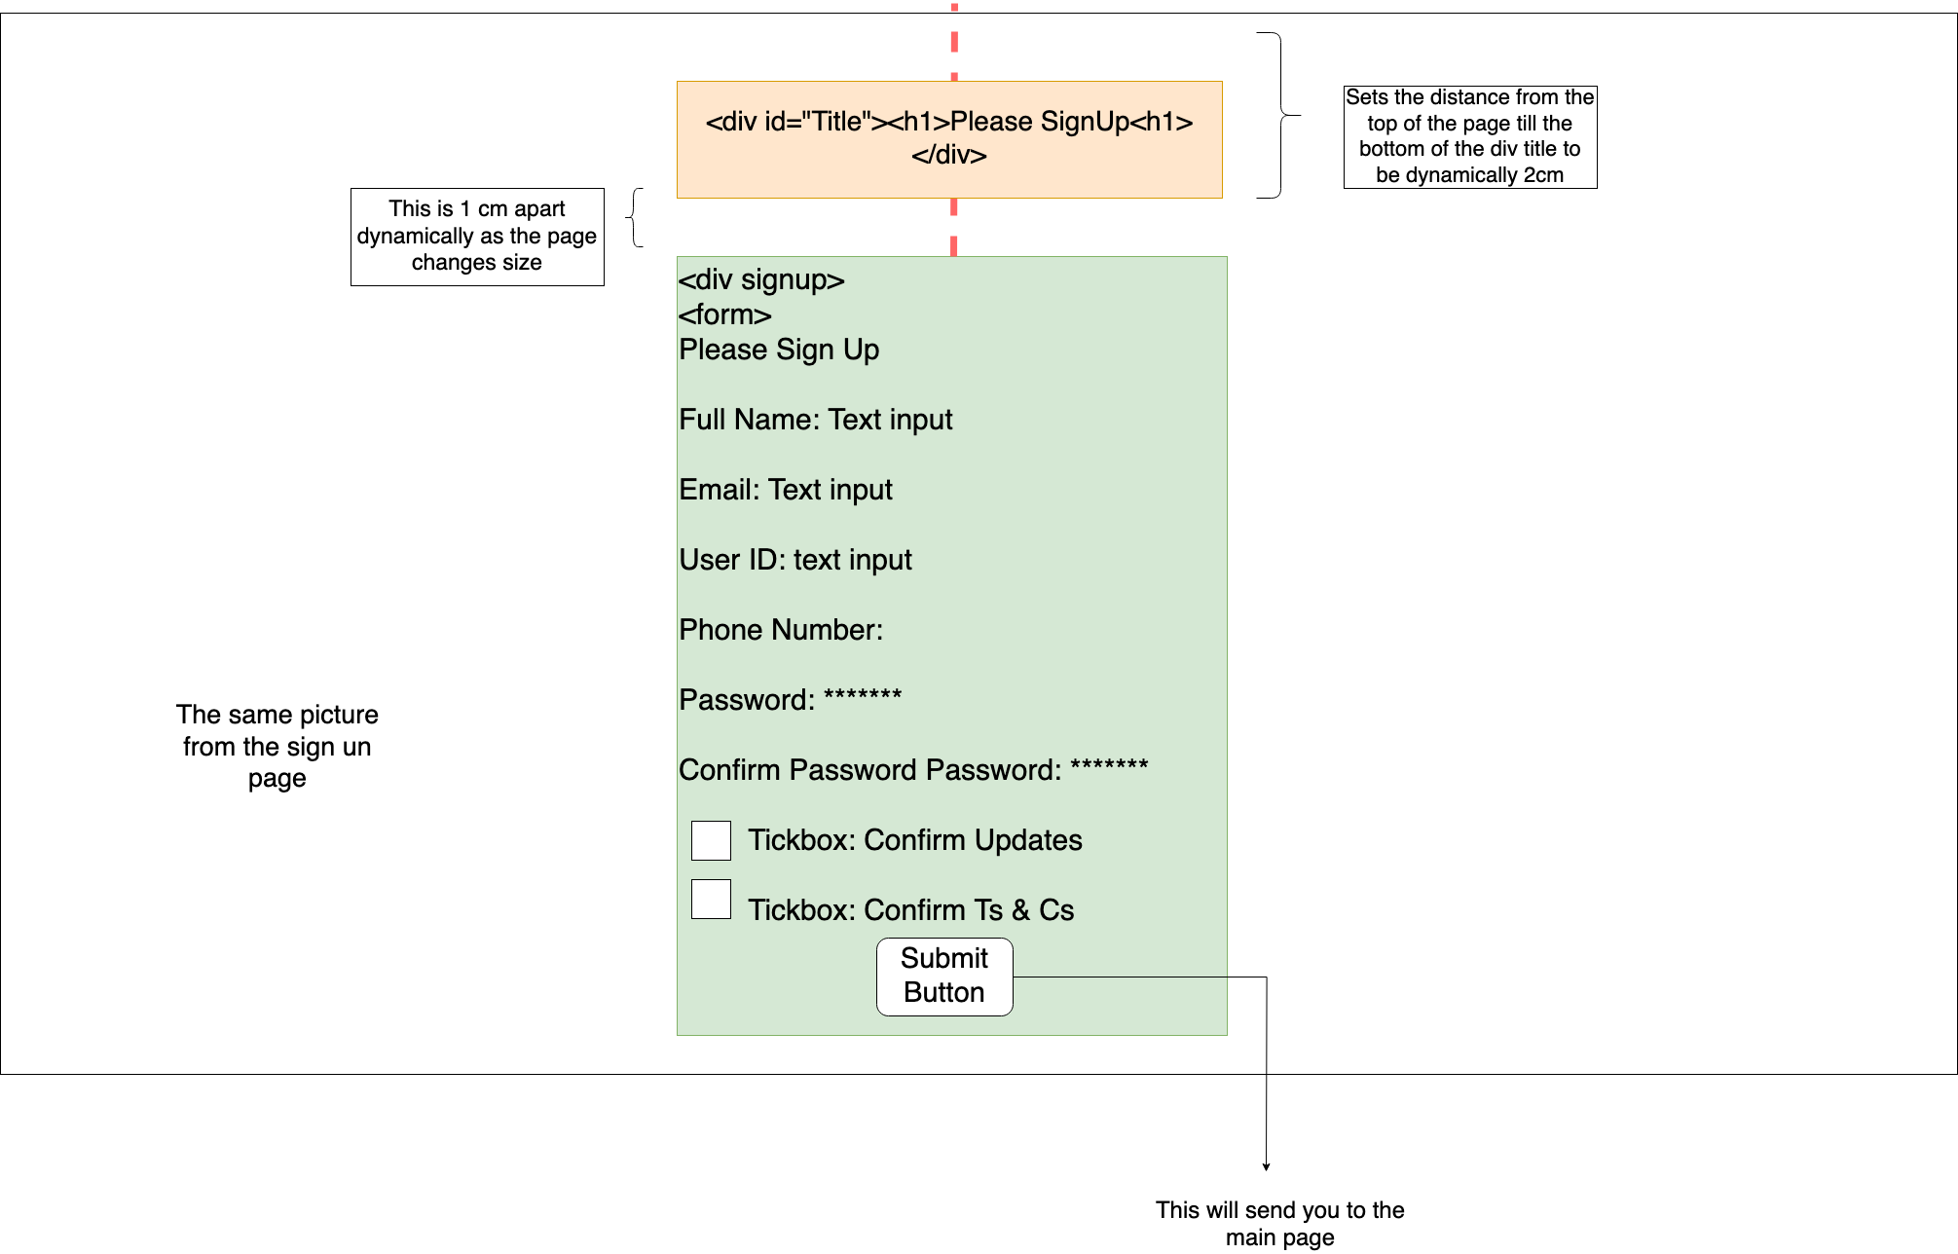

# Sign Up

The sign-up page works similarly to the sign in page. In a sense that the user has the input of their email, full name, their uni student code (a1234567) phone number and the password. Confirm the password will use a javascript to ensure that passwords are valid, and they meet the minimum criteria for a password. The user will also have the choice of accepting to be a part of an automatically sent updates from clubs and events. FInally the tickbox to check if they accepted the terms and conditions as well. The user cannot proceed until all the fields except for the updates field are filled and verified. After which, the user will be redirected to the main page.

Similarly to the sign-in page. This design is ergonomic for the user. As elements are obvious and the placement is central through the page even when the size changes.

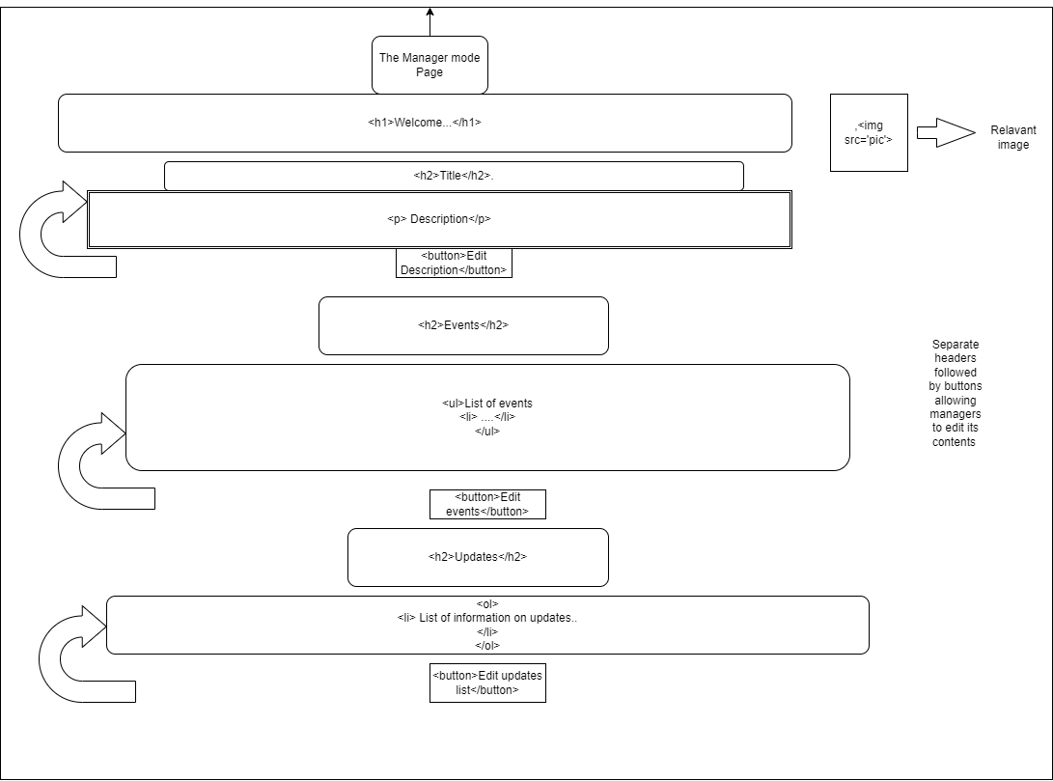

# Manager mode

The Manager page is only accessed by club managers where using simple lists and buttons to update information about various club activities. It also contains headers describing functionalities of each part and also descriptions of the club and a related image.

This is a good design as this will be easy on the user to use as the elements are not too harsh and they are centered,as such the user should find the use of the site easy.

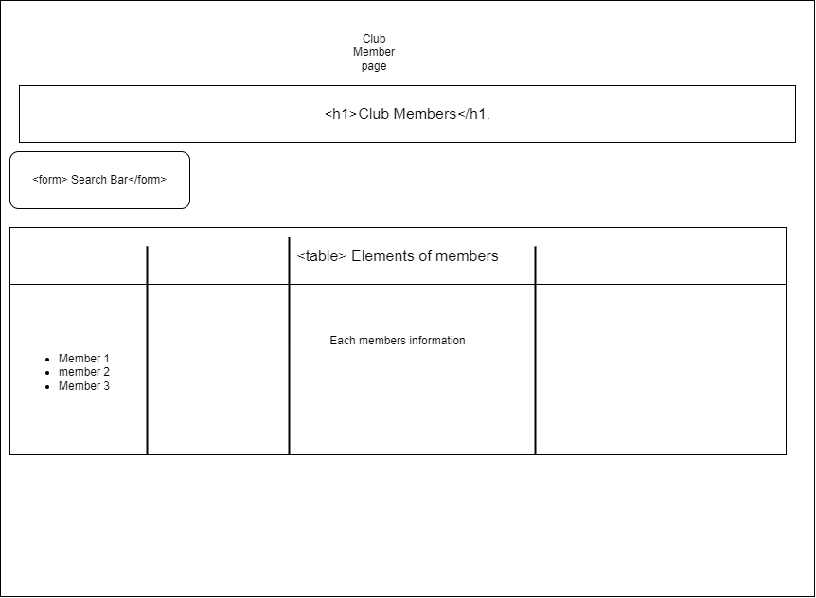

# Club Members

The Club members page makes use of simple tables to store all the information of all the people who signed up as members of the club. It also uses a javascript function and a form to create a search bar if the manager needs to look up details on a particular member easily.

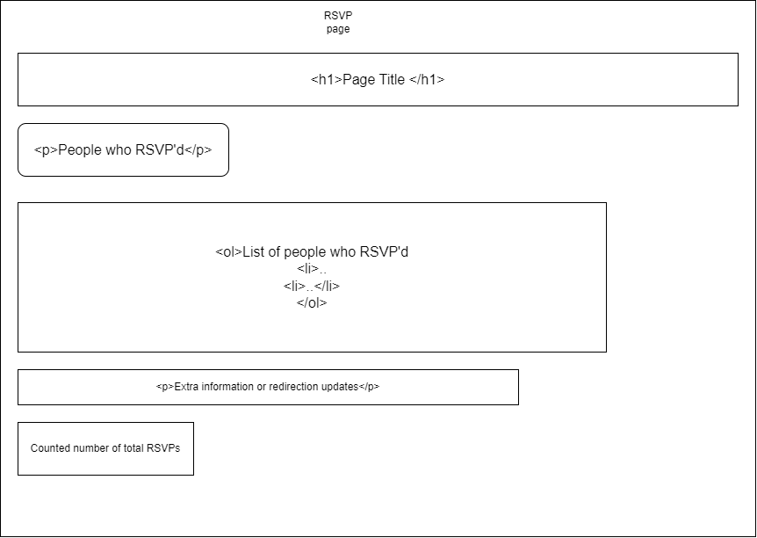

# RSVP list

The RSVP list contains names of the people who confirm their presence in an event in alist, it also contains another Javascript function to count thee total number of entries. It uses DOM functions like get elements and event listeners to update this easily.

# Main Page

## Designs

### Design 1 - Wide

|  |
| --- |
| Design of the Main page - wide.  Width of the page is larger than the height. |

### Design 2 - Tall

|  |
| --- |
| Design of the Main page - thin.  Height of the page is larger than the width. |

## Descriptions

### Title

*Design 1 Section 1*

*Design 2 Section 1*

Main title of the page, something like “University of Adelaide Clubs”.

### Navigation Bar & Sign in/up

*Design 1 Sections 2, 3*

*Design 2 Sections 2, 3*

Navigation Bar / Sign in/up buttons.

Contains links to navigate to other main pages of the website, such as link to a page to view all clubs.

Dynamically changes depending on if the user has logged in or not, if they have it is replaced with a ‘manage account’ button to avoid confusion.

Dynamically changes depending on the size of the view window/port. Design 1 shows the sign in/up buttons inline with the navigation bar where as Design 2 shows the buttons above the navigation bar. Allows for a more clean look.

### Main Content

*Design 1 Sections 4 through 11*

*Design 2 Sections 4, 5*

Contains the main content of the main page.

Design 1 Section 11 shows the main reach of this section, Design 2 Sections 4 and 5 would also be contained (section drawing absent).

The main page shows feeds about relevant information for the user.

Design 1 Section 4 and 9 show the titles of the particular feeds.

Feed entries can be seen in Design 1 Sections 5, 6, 7, 8. The specific sections are title and description. Design 1 Section 7 shows what happens when either the title takes up too much space or if there is not enough horizontal space for both the datetime and title to remain in line.

Design 1 Section 10 shows a vertical scroll bar that appears in the case of not enough vertical room for all feed entries, if the inner content overflows.

The vertical space of these remains the same.

This allows for the overall space being taken up to remain the same, so the user does not have to look in different locations to find what they are looking for.

Design 2 Sections 4 and 5 show what happens in the case of not enough horizontal room for both feeds to remain side by side. They insead sit one above the other.

These feeds are dynamically updates with information.

The event feed will have all events displayed showing the one happening most soon first and least soon last. In the case of a user being logged in, if the user is a part of clubs, it will be restricted to events their club has made and events they have RSVP’d to.

The update feed will have all updates displayed in order of most recent first and least recent last. Again in the case of a logged in user, if they are a part of clubs, the feed will be filtered to only show updates from clubs they are a part of.

This filtering has the end goal of showing the user only what is relevant to them.

The club names, Design 1 Sections 5 and 7, also work as links to their respective club pages.

As do the update names, contained within Design 1 Section 10 on the right side.

### Footer

*Design 1 Section 12*

*Design 2 Section 7*

The footer of the page, containing information a copyright notice, link to a privacy policy, contact information among other information.

# Admin See all Users

## Design

|  |
| --- |
| Design of the Admin See All Users page. |

## Description

### Title

*Section 1*

Main title of the page, something like “UofA Clubs Admin - See All Users”.

### Navigation Bar

*Section 2*

Contains links to navigate to other main pages of the website, such as link to the main page.

There is no sign in/up as the user has already signed in as an admin to view this page.

### Main Content

*Sections 3 through 9*

Section 9 dictates the entire container of the main content.

Section 5, containing Sections 3 (left) and 4 (right), shows an example entry of a user, containing the username Section 3, and a button to go to the account manage page of the user, Section 4.

Dynamically changes if there is not enough room to fit side by side as seen in Section 8, showing the username and manage user button on top of each other.

This has the end goal of providing a cleaner look.

On the right of Section 9 shows a vertical scroll bar that appears in the case of not enough vertical room for all feed entries, if the inner content overflows.

The vertical space of these remains the same.

This allows for the overall space being taken up to remain the same, so the user does not have to look in different locations to find what they are looking for.

### Footer

*Section 10*

The footer of the page, containing information a copyright notice, link to a privacy policy, contact information among other information.

# Admin See all Clubs

## Design

|  |
| --- |
| Design of the Admin See All Clubs page. |

## Description

### Title

*Section 1*

Main title of the page, something like “UofA Clubs Admin - See All Users”.

### Navigation Bar

*Section 2*

Contains links to navigate to other main pages of the website, such as link to the main page.

There is no sign in/up as the user has already signed in as an admin to view this page.

### Main Content

*Sections 3 though 10*

Section 10 shows the container for all the main content.

Section 6, containing Sections 3 (club name), 4 (club description) and 5 (manage club button), shows an example entry.

This entry can dynamically change if there is not enough horizontal room, Section 9 shows this. The club name Section 6 and the manage club button Section 7 are no longer in line.

This has the end goal of providing a cleaner look.

On the right of Section 10 shows a vertical scroll bar that appears in the case of not enough vertical room for all feed entries, if the inner content overflows.

The vertical space of these remains the same.

This allows for the overall space being taken up to remain the same, so the user does not have to look in different locations to find what they are looking for.

The club names Sections 3 and 6, also work as links to their respective club pages.

### Footer

*Section 11*

The footer of the page, containing information a copyright notice, link to a privacy policy, contact information among other information.

# Club page:

## Design

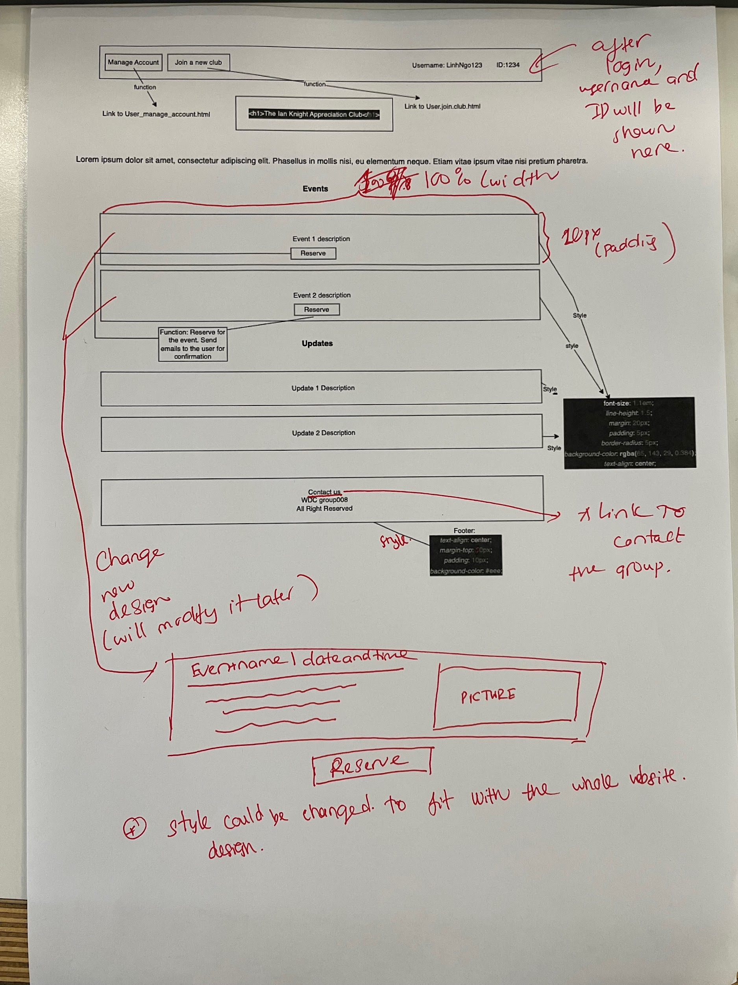

## Description:

Suppose that users have signed up, signed in, and joined a particular club. The user view for a club will be like this.

### Header:

The header of the page will contain a link for users to manage their account and join a new club. These 2 features will be placed in the left hand side of the header. The Username and ID will be on the right hand side.

### Club’s name

Next, the Club name will be under the header as <h1>. It will be placed right in the middle of the screen.

## The club description:

The club description will be after the club name to brief what the club is.

## Club’s events and updates

The club’s events and updates will be listed after this in different divs. Start with club’s events and end with updates. Each club's events will contain: name of that events, date and time of the events. After the user has reserved for the event there will be a pop up window to inform them that they have reserved for the event. They will only be sent an email to confirm that they have reserves for the event. The email will also contain details ( name, day and time of the events and club’s manager’s info to contact when needed).

The reserve button will not be visible to users that are not members of the club. They can only see club’s events and updates but are not able to reserve for that. After joining a club using a link from the header, they can reserve for the club.

## Footer

The footer contains: “contact us” to contact the team, and basic info about the team.

# User Manage Account, Admin Create New Admin and User Join New Club:

## Design:

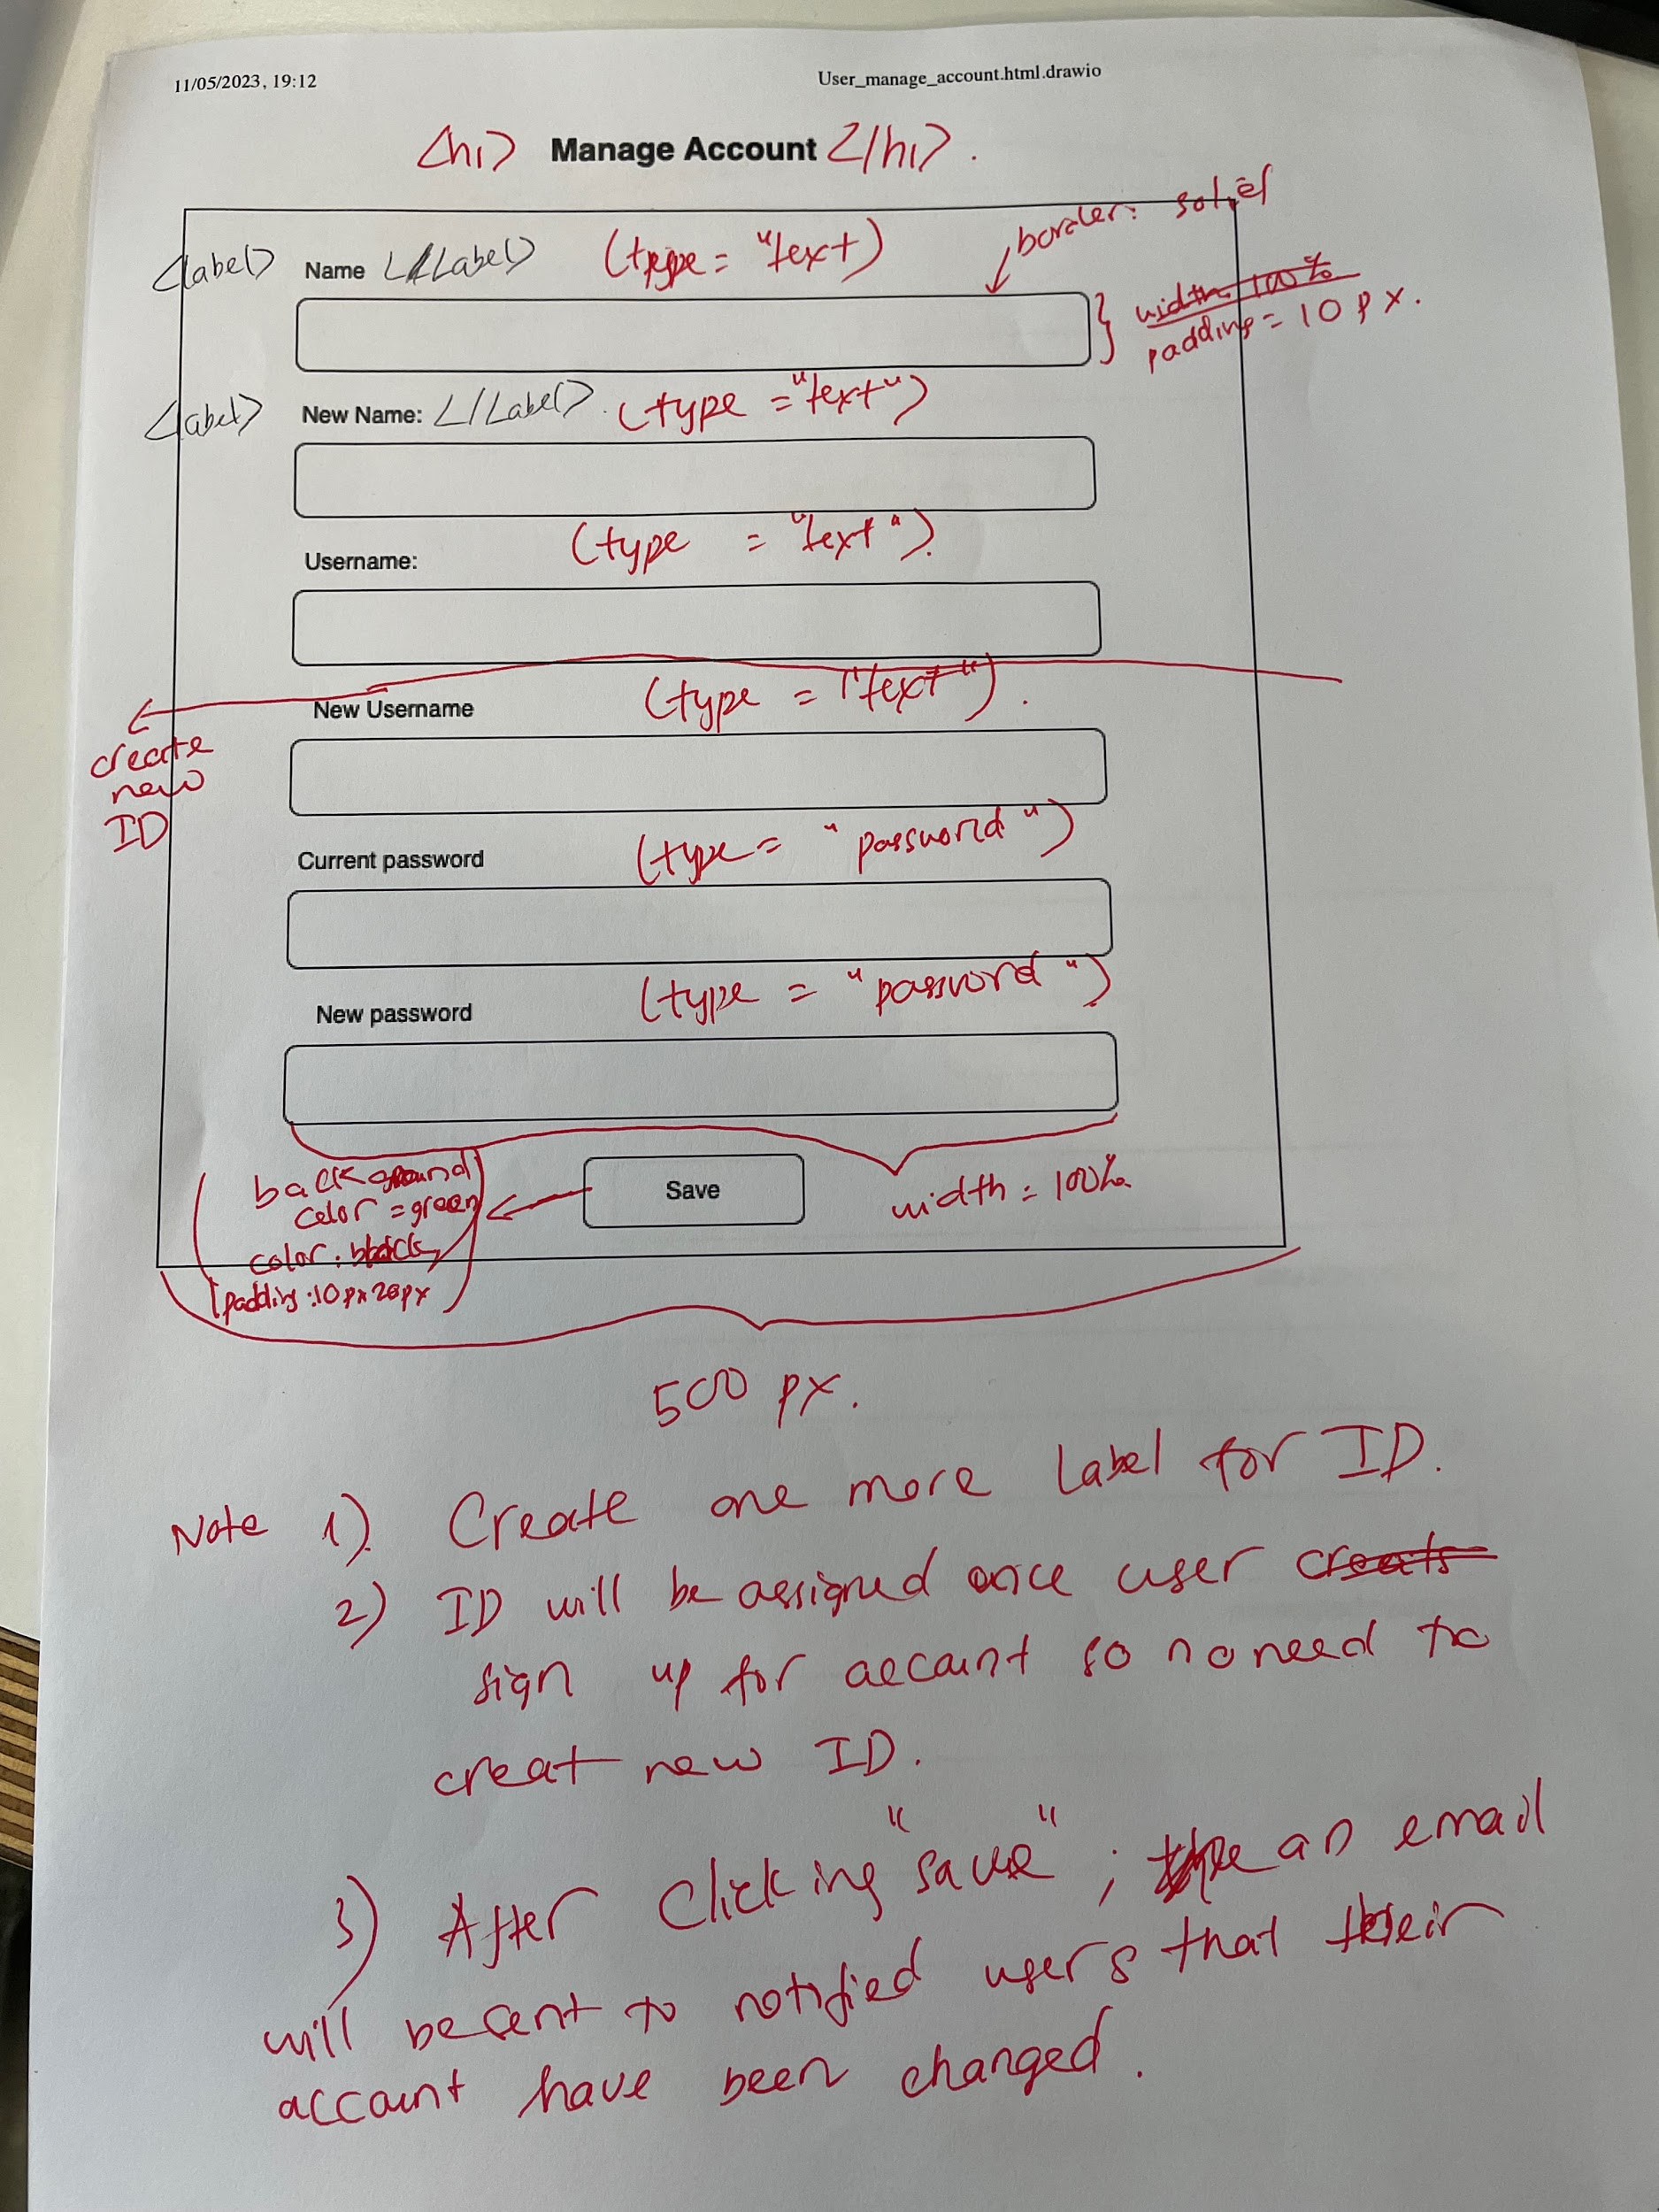

Manage Account

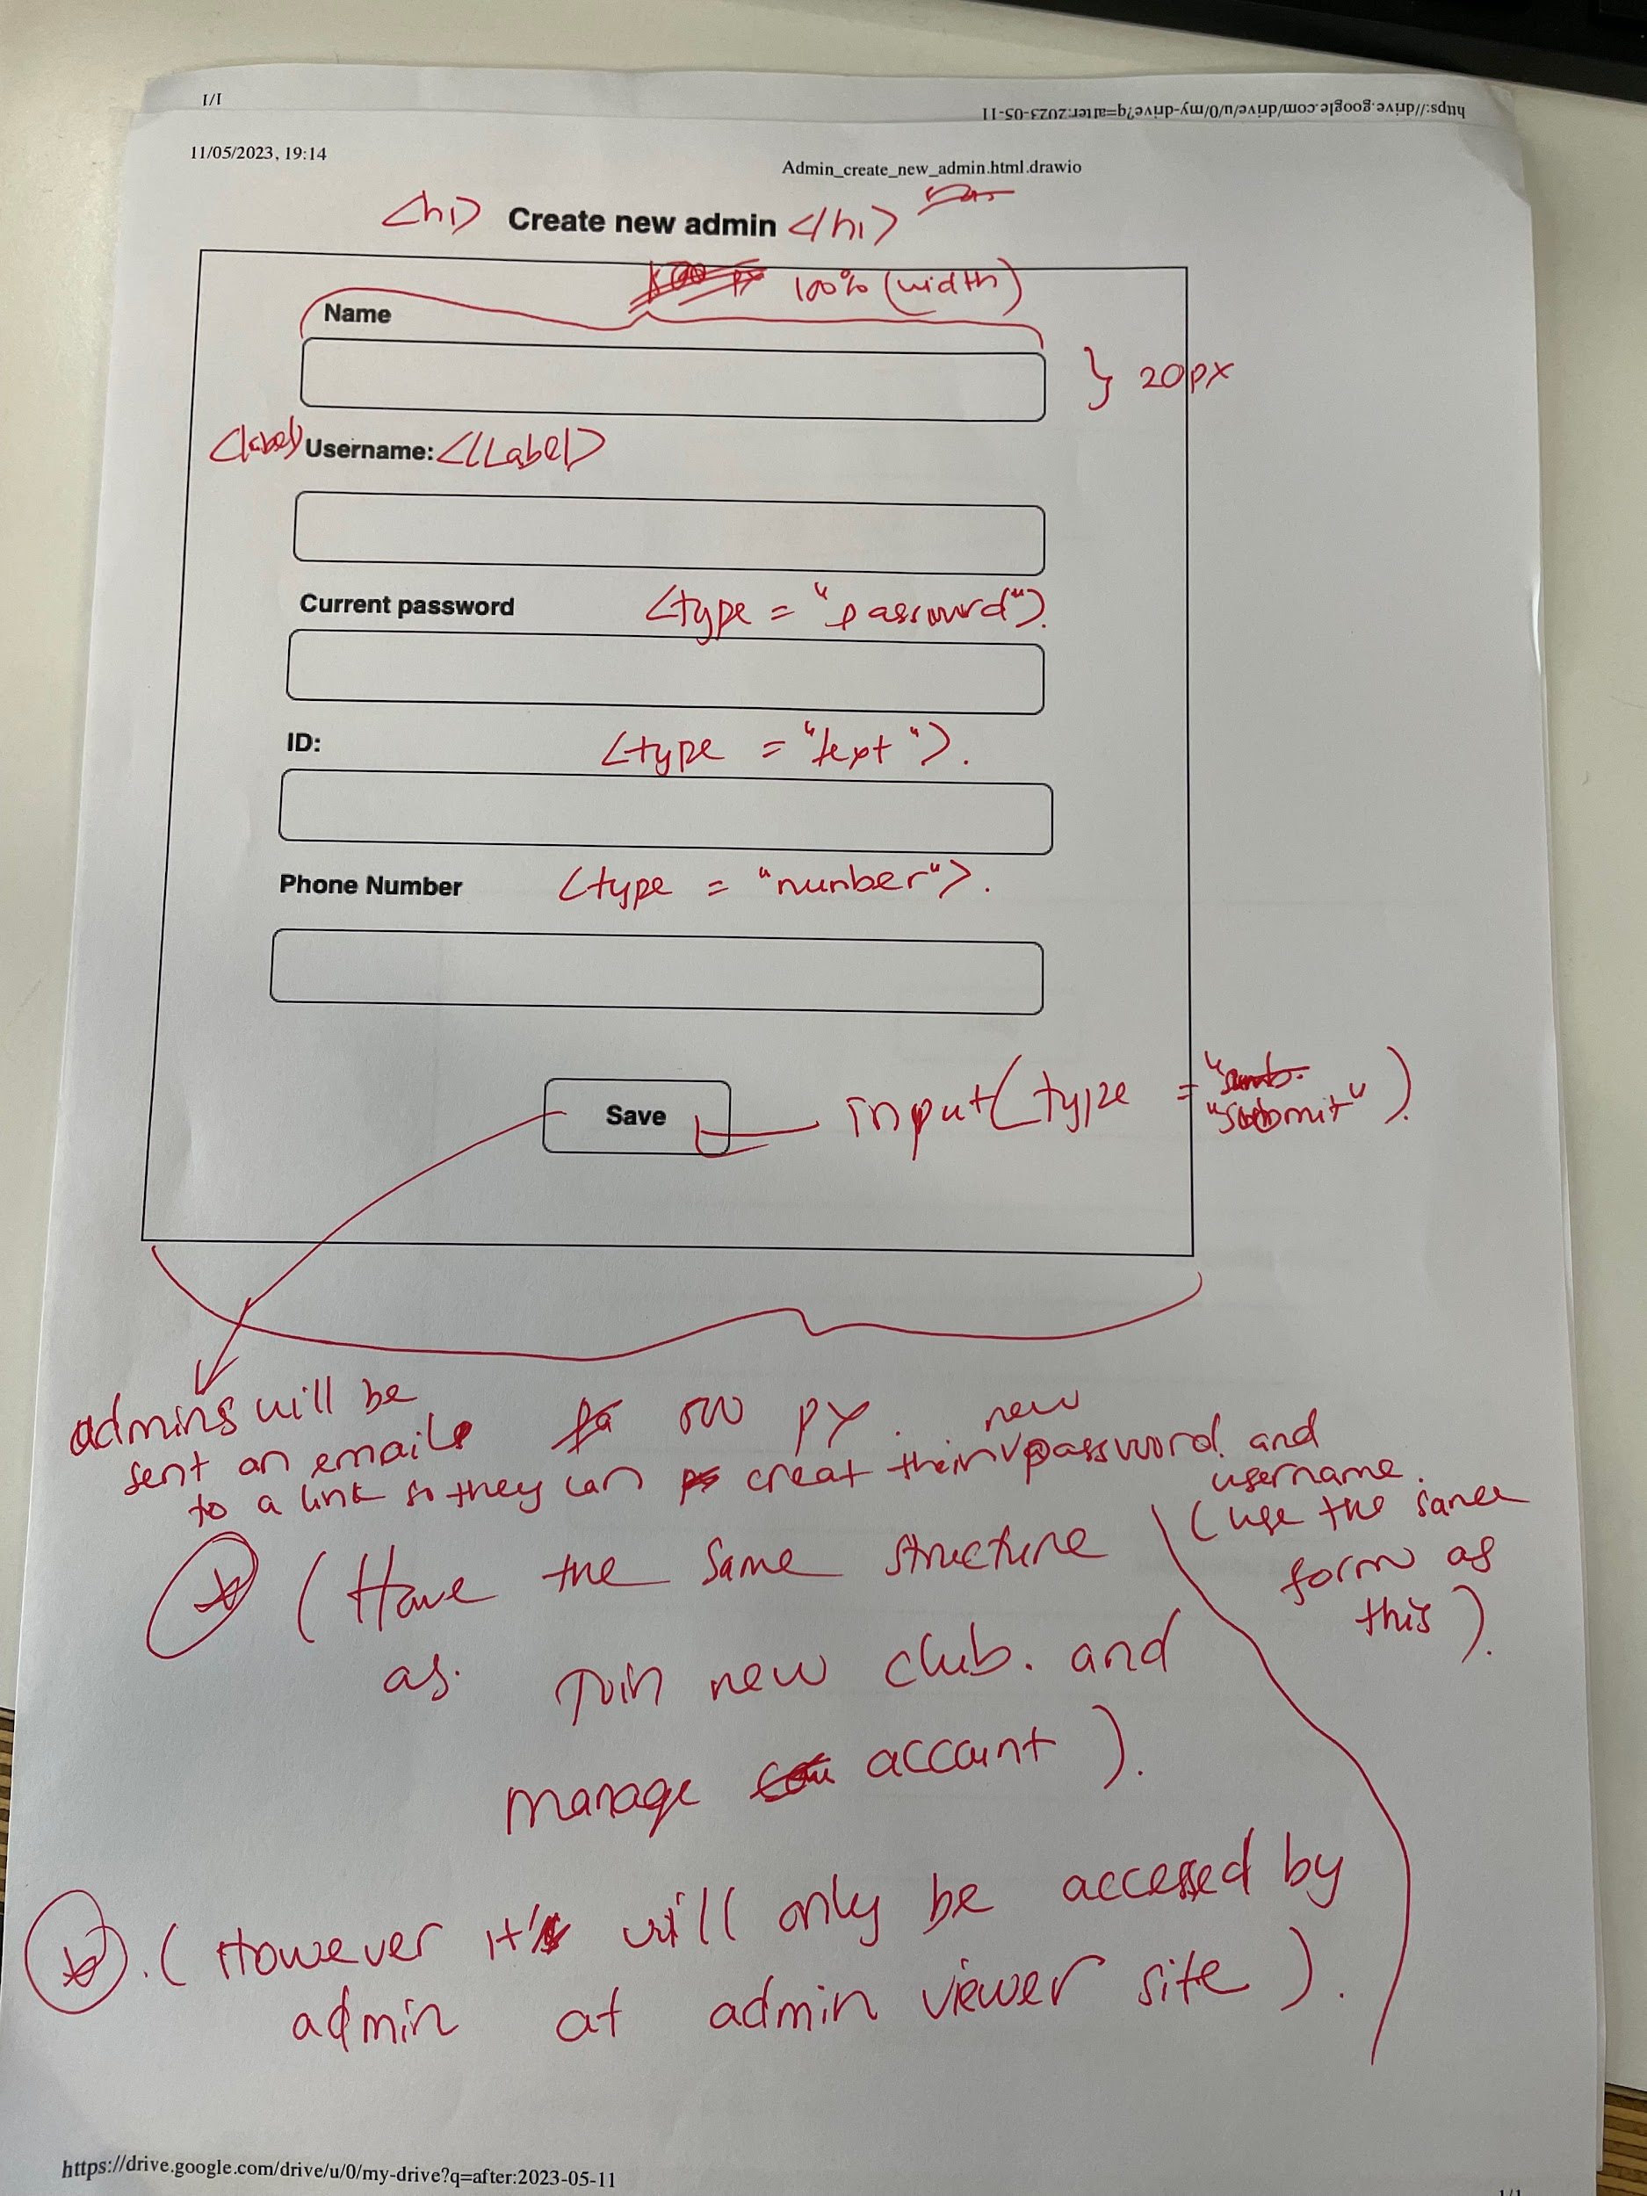

Create new admin

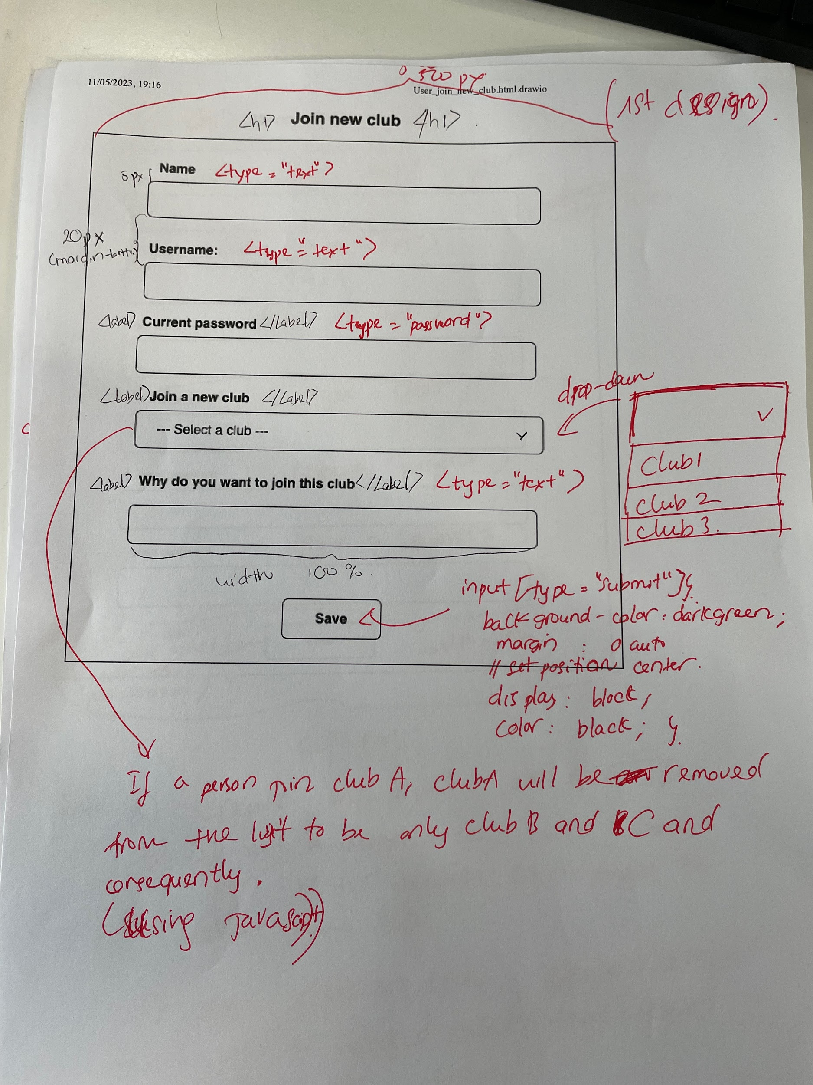

Join new club

## 

## 

## Description:

All three files have the same design but have different features and function, as a result I will be grouped together.

### Manage Account:

This form allows users to change their name, username and password. Save click save successfully, the database will be updated with the user's new data. Also an email will be sent to the user to announce to them that their account has been changed.

### Join new club:

This allows users to join a club after just signing up or want to join more clubs. If a user has joined a club, that club will be removed from the dropdown list. If just signing up the user will have a full list of clubs to join.

### Create new admin:

This allows admins to assign a new admin on his behalf to monitor all activities of the managers and club’s members. The new admin will have his account opened by other admins.